**Lab 9: AC Power**

**Objective:**

Introduce Thevenin and Norton Equivalent circuits for sinusoidal steady state. Develop skills in using PSPICE for sinusoidal steady state analysis and as a design tool.

**Equipment and Components:**

1. Breadboard, Multimeter, Power supply, Function Generator, Oscilloscope.
2. Resistors (3): 1 kΩ.
3. Capacitors (1): 1 μF.
4. Inductor: 1 mH and others as necessary.

**Preliminary:**

Using circuit shown in Fig. 9.1:

1. Calculate the Thevenin and Norton equivalent circuits given a 1 Volt peak 500Hz sinusoidal source.
2. Calculate the type of load required to enable maximum power transfer to the load. Specify the components for a series equivalent load. What is the maximum average power transferred to the load?
3. Verify your Thevenin and Norton equivalent calculation using a SPICE simulation. Leave the end terminals open for VTH (For RTH, assume that your calculation is correct).
4. Verify that the load from part 2 will provide a maximum power transfer using simulations. *Note: This can be done by probing the current through the load. Check to see if this amplitude value matches the one you calculated before. Make sure to enter the exact value for the load.*
5. If the frequency of the source is increased to 50 kHz in the simulation, does the load still enable maximum power transfer? If not what would have to be changed?

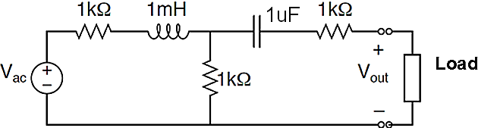

Fig. 9.1: AC circuit to be analyzed

**Procedure:**

Construct the circuit in Figure 1 and conduct the following:

1. With the function generator connected to the circuit, attach probe 1 of the oscilloscope to the function generator’s output and adjust the it to produce a “loaded” 1 Volt 500 Hz sinusoidal signal.
2. Measure both the magnitude and phase of Voc (=VTH) and Isc (=IN) at 500 Hz, and calculate Zth (=VTH/ISC).
3. Construct the matched load calculated in preliminary.
4. Verify that this load provides a maximum power transfer at 500 Hz. *First, measure rms voltage and rms current across the load using multimeter. Then find power. This value should match the calculated and simulated values.*
5. Now change the frequency of the source to 50 kHz. Observe the differences in the power transfer to the load. How can you improve the power transfer at this frequency?

**Conclusion:**

Compare your preliminary calculations to your simulation and measurements, summarize in a table with % errors. Give plausible reasons for the discrepancies.